Name ______________________________________

CS 142 Final Exam
Version 0.15
Instructor: R. P. Burton

April 19-24, 2013 (Friday through Wednesday)
due in the Lab on Wednesday not later than 8:00 p.m.
Penalty for submitting the final exam late: 100% (i.e. no late submissions)

Allowed materials include your CS 142 course text, your own notes, your own prior lab solutions, the CS 142 course website, and cplusplus.com
Disallowed materials include all other text resources, all other Internet
resources, and all neighbors (remember, everyone is thy neighbor)

*Instructions*
(Please read carefully)
1. This exam consists of a C++ programming problem. Read and understand the statement of the problem completely before beginning to design, code, and test. As part of your design, consider the test cases that will establish the correctness of your solution.
2. Produce a solution, which consists of your C++ code, with a comment which includes your name, your student ID number, and “CS 142 Winter 2013 Final Exam.” Save your complete source file(s) using the online submission script. Attribute any code taken from or based on other sources (except for the course text and the course website). Code copied from or based heavily on outside sources is worth half credit.
3. Understanding the problem correctly is part of the examination. If something seems unclear, ask a CS 142 TA for clarification. You may pose questions to the CS 142 TAs at any time. However, the TAs generally are not permitted to answer questions related to design, implementation, debugging, or testing.
4. Code well. This includes choosing good names for identifiers, providing appropriate classes, avoiding magic numbers, choosing good control/repetition structures and appropriate data structures, using encapsulation, inheritance, polymorphism, recursion, etc. as appropriate, minimizing orders of complexity, formatting in a communicative way, etc. so that your code is reasonably self-documenting. Provide comments where appropriate, especially to help the TAs understand what your code is intended to do. Remember, you will be graded not only on whether your code (when entered, compiled, and executed) accomplishes the specified task, but also on how clearly and efficiently it accomplishes the specified task, and on how closely you adhere to the stated requirements and to good programming practices.
6. When you are finished, score your solution as indicated on the Scoring Sheet. fabs (your_score – the_TAs_score) * 0.5 – 5.0 will be subtracted from your score. Then go to the course website and follow the link labeled “Submit Exam” in the Exam Menu.
7. Your submission must compile on MS Visual Studio 2010 (the lab machines). If it does not compile on those machines, you will forfeit 20% of your final score.
9. You must submit this exam packet and your code under a TAs supervision. The TAs need your exam packet to post your score. If incorrect files are submitted for any reason, you will lose 26 points on this exam. Submit everything with a TA present to protect against this loss.
10. Sign here (a) to certify that you have reviewed your posted scores for the semester and that you have alerted a TA in writing to any missing or incorrect scores, (b) to request that your final exam be graded, and (c) to certify that no unfair information related to the final exam has been received by you, either directly or indirectly, and that none will be conveyed by you. If we discover that you cheated or assisted someone in cheating, intentionally or unintentionally (including accidentally), your score for this exam may (and probably will) be

rand() % 1
We’re serious.

____________________________________________ ___________________, 2013
(signature) (date)
Paying Your Dues

Background:

You’ve just purchased a home in a subdivision that has been incorporated as a Property Owners Association (POA). The POA consists of privately-owned lots and some common facilities (a perimeter fence, private roads, a clubhouse, a pool, a stream with walking paths, etc.). The common facilities are owned jointly by all members of the POA.

There are two types of main lots: inside lots and outside lots. Lots interior to the POA are called inside lots; the lots around the outside of the POA are called outside lots. The POA provides full landscaping services (installation, maintenance, replacement as needed, etc.) for all inside lots. The POA provides no landscaping services for outside lots.

A main lot owner can purchase an adjacent landscaped lot to add to the open space associated with his lot. Each owner may own only one main lot: either an inside lot or an outside lot. In addition, an owner of a main lot may own at most 1 adjacent lot. Some lots have homes; others do not. A lot without a home can have a home built on it at any time, except for adjacent landscaped lots which can never have a home.

Lots are charged a monthly fee of $100 to pay the costs associated with the common facilities, except for adjacent landscape lots which are charged only $75 per month. All lots with homes are charged an additional $30 each month to pay for Internet and cable connections. Inside lots with homes are charged an additional $40 each month for regular landscaping services; inside lots without homes are charged only $20 each month. A lawn mowing fee of $10 is imposed for each week that the owner of an outside lot with a home or the owner of an adjacent landscaped lot fails to mow his lawn. A periodic weed treatment fee of $50 is imposed when the owner of a vacant outside lot (i.e. an outside lot without a home) fails to treat his weeds. A lawn mowing fee may be applied up to 4 times per month per lot. A weed treatment may be imposed at most once per month per outside lot.

Specifications:

The POA wants you to write a C++ program to
- add a new lot to the POA (providing a lot number, the owner’s surname, and the lot category); if the lot is acquired as an “adjacent landscaped lot,” the owner’s surname must match the surname of an existing lot owner
- impose a lawn mowing fee on an outside lot with a home or on an adjacent landscaped lot
- impose a weed treatment fee on a outside lot without a home
- sort a vector of lots by lot numbers or by surnames
- compute and report the monthly dues

Requirements, Constraints, Clarifications, and Recommendations:
- Extend the provided interfaces (POAInterface.h & LotInterface.h)
- Complete the provided Factory class
- Begin by designing an appropriate inheritance hierarchy (which can be drawn by hand or by any other appropriate means); attach a copy of your inheritance hierarchy to you exam packet. For lab 10, the inheritance hierarchy looked like this:
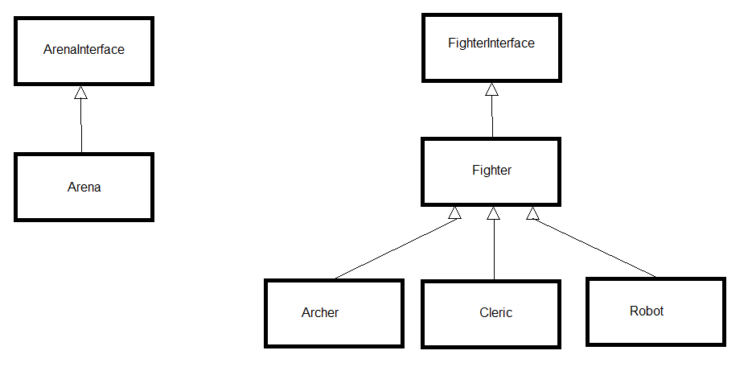
- Build your solution one piece at a time.
- Store all the lots in a single vector.
- Do NOT store the lot type as a data member; use objects of different classes related to each other in your inheritance hierarchy.
- Use polymorphism appropriately as you iterate through your vector to produce the monthly report.
- If lawn mowing or weed treatment fees are imposed, those fees are included only in the next monthly dues. The month advances when the endMonth() function is called (see the POAInterface.h); imposed fees are billed and removed.
- It is suggested that you write your own main function to test your program. A test driver will be used for the final testing as was done for lab 10. You will not have access to this test driver.
Final Exam Scoring Sheet

Name:_______________ Received By(TA Signature):____________________
Approx. Hours Spent taking Exam:_____________

***If your solution does not compile (i.e. has red squiggles), your score will be reduced by 20%***

Student Grading TA Grading
___/ 15 pts ___/ 15 pts – Inheritance
___/ 10 pts ___/10 pts – Uses a correct inheritance structure
___/ 5 pts ___/ 5 pts – Includes a drawing of the inheritance hierarchy
___/ 40 pts ___/ 40 pts – Lots
___/ 10 pts ___/ 10 pts – Provides all required functionality for outside lots*
___/ 10 pts ___/ 10 pts – Provides all required functionality for inside lots*
___/ 10 pts ___/ 10 pts – Provides all required functionality for adjacent lots*
*Includes all required calculations/fees
___/ 5 pts ___/ 5 pts – Uses appropriate data members for each lot class
___/ 5 pts ___/ 5 pts – Turns a lot without a home into a lot with a home
___/ 35 pts ___/ 35 pts – Execution
___/ 10 pts ___/ 10 pts – Sorts by lot number and/or surname
___/ 15 pts ___/ 15 pts – Allows addition of new lots of any type to the POA
___/ 5 pts ___/ 5 pts – Stores all lots in a single vector
___/ 5 pts ___/ 5 pts – Resets fees after a month is over
___/ 10 pts ___/ 10 pts – Coding Style
___/ 5 pts ___/ 5 pts – Correct indentation, visual neatness
___/ 5 pts ___/ 5 pts – Descriptive variable names, comments as needed

___/ 100 pts ___/ 100 pts – subtotal (before late and incorrect submission penalties)
___/ 100 pts ___/ 100 pts – subtotal (after late and incorrect submission penalties)
___ Instruction 6 adjustment
___ TOTAL

Student-to-Grading TAComments:__________________________________________________________
__________________________________________________________________________________________________________________________________________________________________________________________________________________________________________________________________

Grading-TA-to-Student Comments:_________________________________________________________
_____________________________________________________________________________________________________________________________________________________________________________________________________________________________________Grader Name:__________________

